**UNIVERSITY INJURY REPORT**

BE DETAILED. USE BLUE OR BLACK PEN ONLY. SUBMIT COMPLETED REPORT TO YOUR ADVISOR.

Person Completing Report: ___________________________ Phone: ___________________________________

Injured Person: ________________________ Phone: ___________________ E-Mail: ______________________

STUDENT ID#: ________________________ Parent/Guardian Phone: ___________________________________

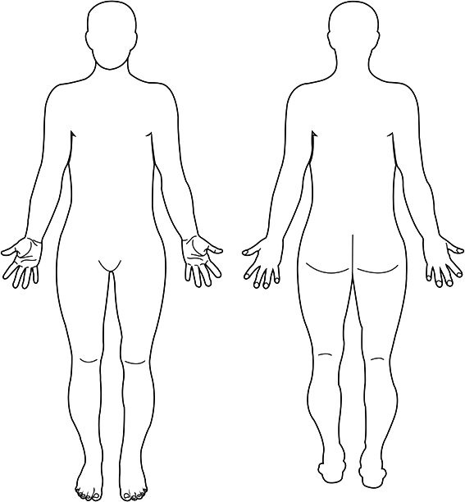**Injury** (Circle body part(s) and describe injury):

**Pertinent Medical Information** (Has injury occurred before?):

**How Accident Occurred** (Describe. Include program area/group & activity): Date: _________ Time: _________

**Location of Accident** (Describe):

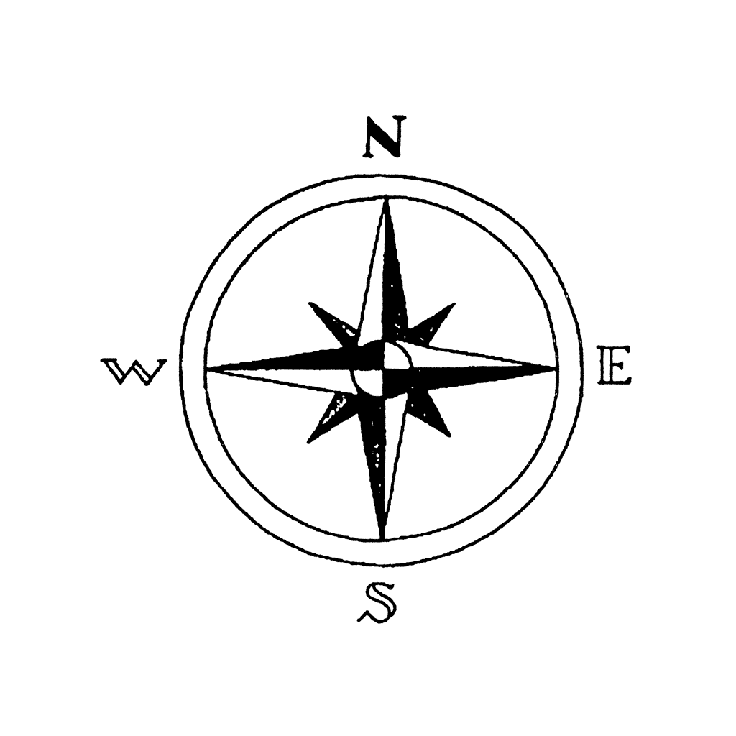**Diagram Location of Site Where Accident Occurred:**

**Person Taking Action:** ________________________________ **Phone:** __________________________________

**Action Taken/Assistance Given:**

**Emergency Services**

911 called? 911 called by staff?

UPD called*? 911 care refused by participant?

Participant refused care by Club Sport staff?

*If Emergency Care Services (911) is called, ensure that UPD is also notified at the same time.

Always inform injured participants that they should seek further medical attention if their injury lasts or worsens. Staff are not medical professionals and therefore cannot make a diagnosis of any kind.

**Witnesses**

Name: __________________________ Phone: ______________________ E-mail: ________________________

Name: __________________________ Phone: ______________________ E-mail: ________________________

I will NOT hold Southern Arkansas University or the Club Sport Administration/Staff liable for any injury resulting from treatment provided. I understand that the Club Sport Administration/Staff are not medical professionals and cannot diagnose my condition; therefore, I am advised to seek further medical treatment. I have read this report and agree that the information is accurate.

Injured Participant’s Signature: _________________________________ Date: _______ /______ / ___________

**Additional Comments:**

**Official Use Only**:

Participant Follow Up **YES NO Date Time**

Left message/E-mail (circle medium used) ____ ____ ________ ______

Spoke to Injured Participant ____ ____ ________ ______

Spoke to Parent/Guardian ____ ____ ________ ______

Additional Notes:

**SUBMIT COMPLETED FORM TO CLUB SPORT ADMINISTRATION** Date Submitted: __________